# Z E D E D U C A T I O N

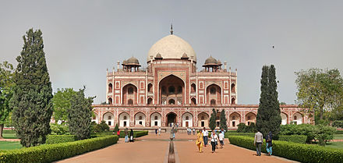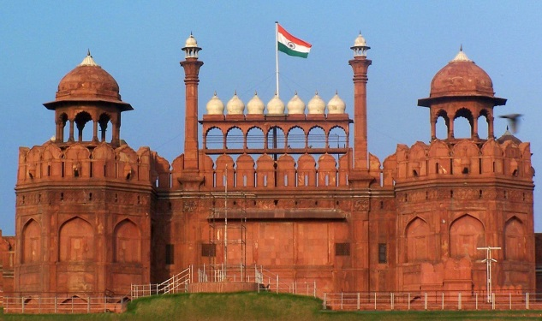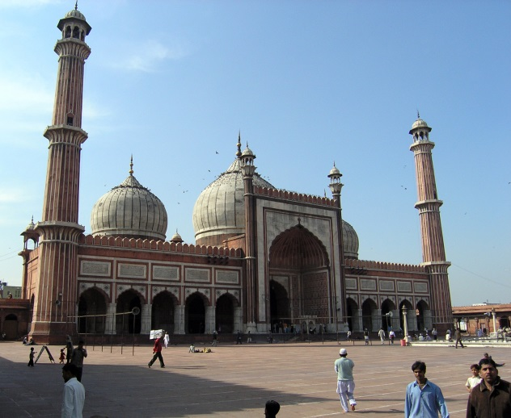

**Maqbarah-E-Humayun**

Maqbarah-E-Humayun, (Humayun’s Tomb), is the tomb of the emperor Nasir Ud-Din Mohammed Humayun who had once ruled from modern day Hindustan (Hindustan is the Indian name of India, particularly the northern areas) to Afghanistan. He ruled from 1530-1540 and again from 1555-1556. After the death of Humayun, his wife Haji had the tomb contructed in 1570. Inside the walled enclosure of Maqbarah-E-Humayun, there are garden squares, water channels and pathways as well as the monument which holds the emperors tomb. There are also the graves of other emperors of Hindustan.

**Jama Masjid**

Jama Masjid (meaning Friday Mosque) is the largest mosque in Hindustan, and the 8th largest in the world, holding upto 25000 people. It was constructed by the emperor Shah Jahan, who had also constructed the Lal Qila and the Taj Mahal. Jama Masjid was built between 1644 and 1648 with red sandstone and marble by over 5000 artisans.

**Lal Qila**

Lal Qila (Red Fort) was the place of residence of several Mughal emperors for nearly 200 years until 1857. The red sandstone walls of the fort rise 33 meters high and were designed to keep out invaders. Contrustion began from1638 and were completed by1648. Within the walls of the fort lie Lahori gate, Delhi Gate, Mumtaz Mahal, Naubat Khana, Diwan-E-Aam, Diwan-E-Khas and many other structures.

A passport valid for at least 180 days and with at least two blank pages is required as well as a visa. Canadians must be in possession of a visa to visit India. You must obtain a visa prior to arrival or you will be refused entry into the country.

Holders of tourist visas can only stay in India for up to 180 consecutive days, even when the validity of the visa exceeds 180 days.

Travel Requirements

Trip to Delhi

## Lead Story Headline